Company Database Schema
- Create Database using wizard with the following schema then
Create DB Diagram and insert at least 2 rows per table
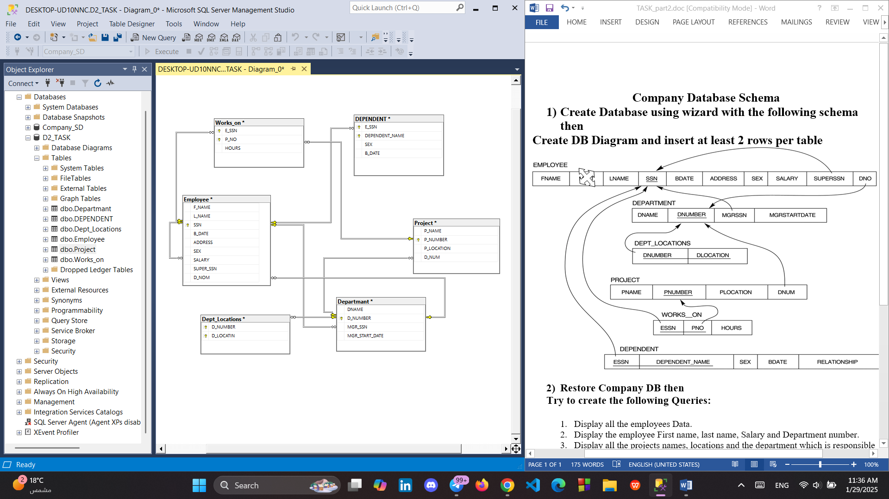
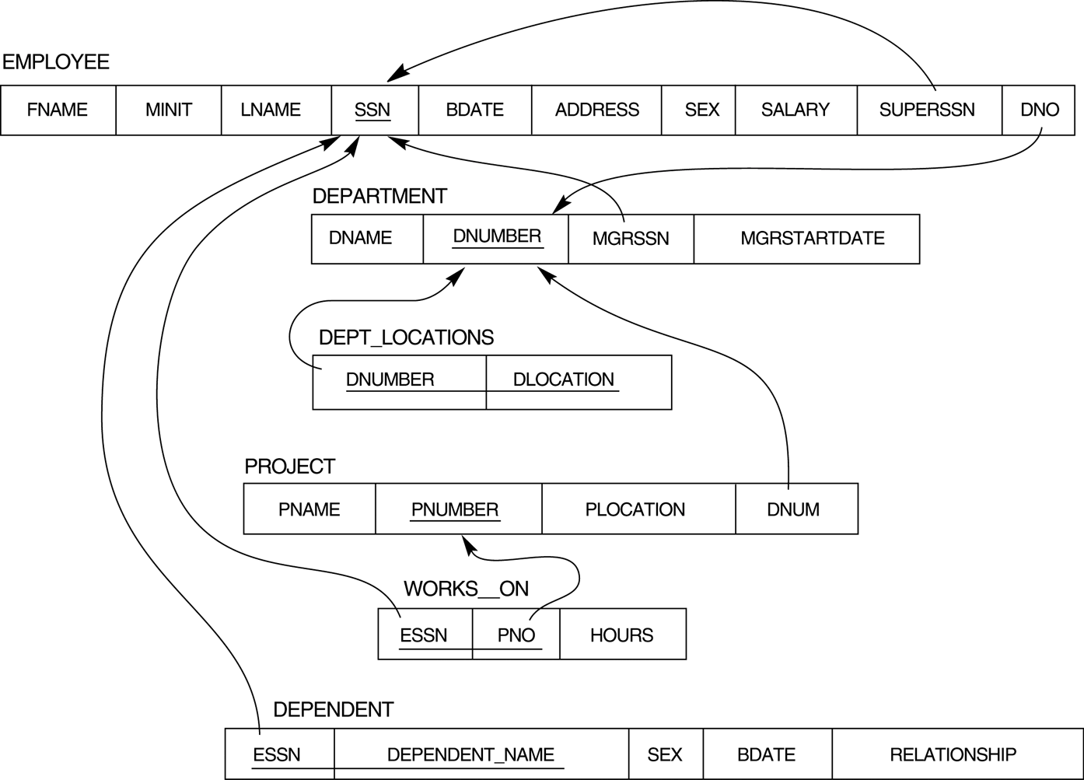
solution
=============================================

